A SMART HOME AUTOMATION PROJECT BASED ON

INTERNET OF THINGS (IOT)

BY

ASOMBA EMMANUEL CHINONSO

2012364126

NNAMDI AZIKIWE UNIVERSITY, AWKA, NIGERIA

OCTOBER 2017

Project Operational Manual

This proposed smart home, as described will consist of three main parts, which will include;

* A user friendly software interface which will run on the (smart phone)
* A hardware module
* Micro-web server

This proposed system will integrate devices such as light switching, automated door access and temperature sensor, the proposed system is flexible and can be modified to support other devices, in other to show how flexibility, efficiency and effectiveness of the system, the most important feature of the software application is to present and provide a user friendly interface which the user can interact with, while it hides from the user several other processes need in running the system effectively. Other important feature of the application will include:

* Establishment of a remote connection to the micro-web server
* Device control and monitor
* Voice feedback depending on action implemented
* Ability to perform sensing and actuating function via specific voice commands

User-Guide Figures

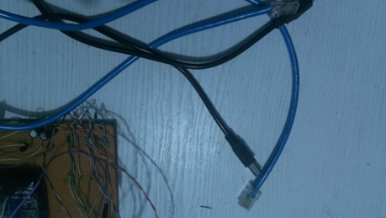

RJ-45 Cable

Arduino Power Supply Cable

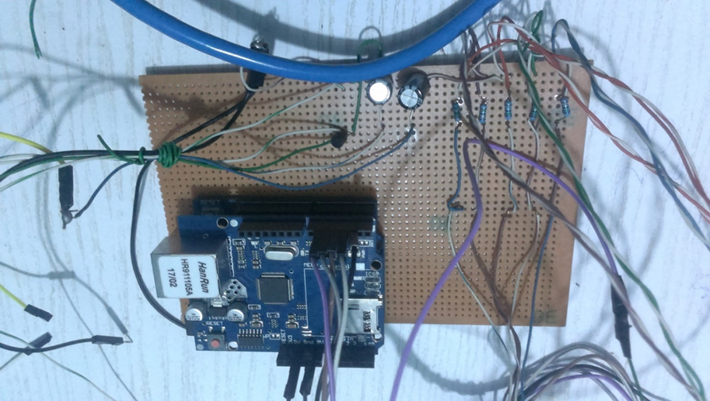

Arduino power supply socket is located directly beneath, the arduino RJ-45 socket

Arduino RJ-45 socket

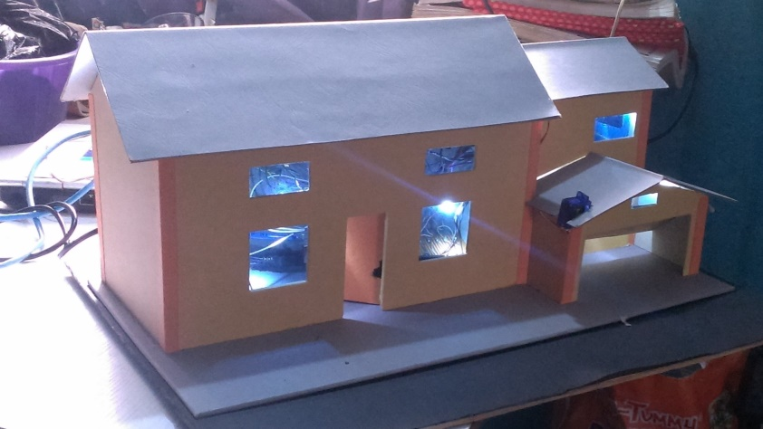

The Model House

How to Operate the Work

1. Connect the RJ-45 cable to the any wifi-router, (please ensure that the other end of the RJ-45 cable is connected to the arduino Ethernet shield socket)
2. Power the arduino by connecting its to the 5v power bank or a 5v power supply using the arduino power supply cable
3. Power the router ON by connected it to a power supply
4. **Please note**, the arduino transmitting and receiving light must be ON now, this light is marked by Tx and Rx blinking, to be on a saver side, on powering on the arduino the arduino click the reset button on the arduino Ethernet shield once.
5. Install the android application on any smart phone that support the android operation systems
6. Connect the smart phone to the Local Area Network created using the router and Ethernet shield, using the WIFI functionality on the smart phone
7. Open the application, proceed to clicking the “Control device” button to Access the interface to control the lighting points and other functions in the model home

Any change in the default IP address and port Value, must be reflected in the source code on which the arduino micro-web server runs

Things to Note

After the setting up the micro-web server, the following will be observed;

On opening the smart phone application, a platform is given for the user to enter the specified IP address and port no of the micro-web server or arduino server, which on entering, a user can access the devices, actuators, appliances and sensing modules connected to the home as seen in figure 1.1 below, please refer to figure 4.0 in project write up for the flowchart of the system design for more details

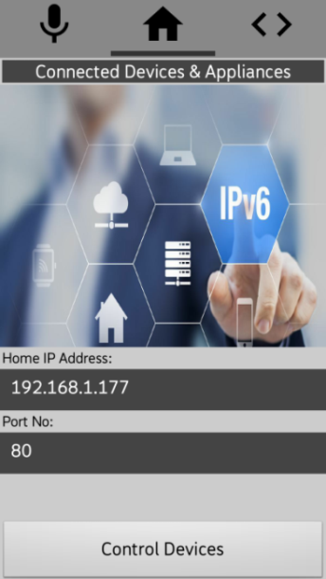 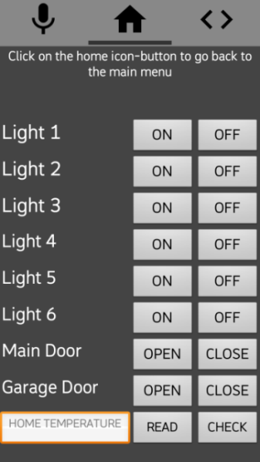

Figure 1.1 when user opens phone application

* The Smart phone application will not perform any operation if the system is not connected to the micro web server as in figure 1.2, in a case where it senses data connection but not from the server, the intended command will be sent but will not be implemented, in a case where it is unable to implement the sent command, it application will produce a Notification message and a voice feedback message alerting the user of the failure of the software client to reach or transmit the sent command to the server,

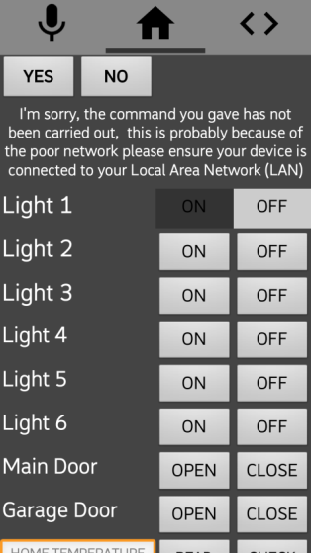

Figure 1.2 when software client is unable to connect

* On establishing connection with the micro-web server, we can control the devices and connected appliance by changing the states of each device, depending on the user preferences, figure 4.5 shows the all lighting points of the model home been turned ON via the user software and the corresponding effect on the home as seen in figure 1.3b

Here a voice feedback accompanies the implementation of the transmitted command,

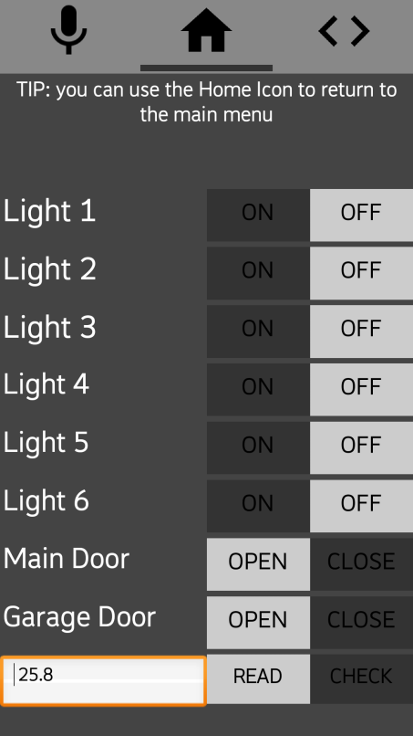 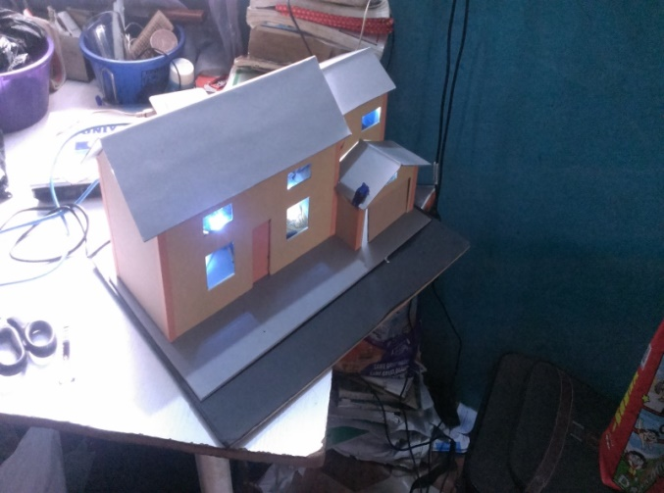

Figure 1.3 controlling the various lighting point in the model home

* It can be observed that from figure 1.4 below that sensing and actuating function such as automated door access and home temperature detection can be performed by the user software, as in figure 1.4b we would be opening the Entrance door to the home and the Garage door in the home from the user smart phone

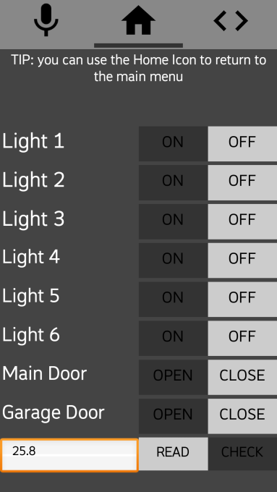 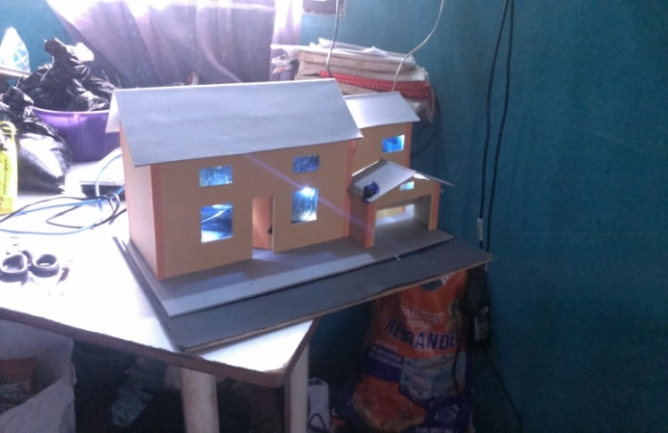

Figure 1.4 monitoring home temperature, automated door access into the building via the user smartphone

* Another important feature of this software is it ability to accept voice commands, depending on the question queried by the system personal assistant / virtual home manager, user needs only to reply accordingly {ON or OFF}, for switching lighting points {OPEN, CLOSE}, opening or closing garage door, {YES or NO} reading or checking room temperature, here light six is been turn ON, this is achieved by the user replying “on” to the question asked.

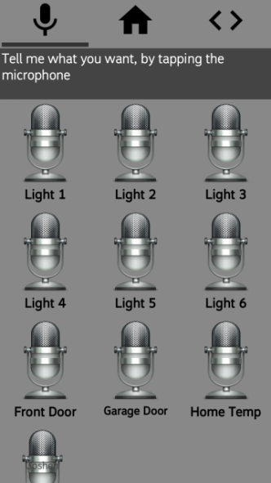 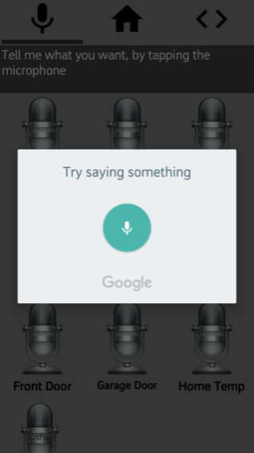 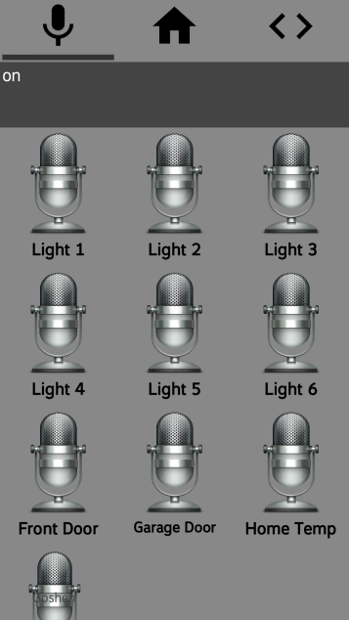

Figure 1.5 showing the voice command demo

|  |  |  |  |
| --- | --- | --- | --- |
| S/N | NAME | REG NO. | PHONE NO. |
| 1. | Asomba Emmanuel Chinonso | 2012364126 | 08164975474, 09032117065 |

Supervisors:

Engr. Dr. Adrian Udenze (Project Supervisor)

Engr. Herbert Ejiofor (Project Technician)